Feature Request:

No repeated tracks in playlists
April, 13. 2024

OBJECTIVE
Avoid duplicated tracks in the user playlist.

BACKGROUND
Create a new playlist with mixed artists, albums or genres, have one thing in common: diversity.
It takes time to create a playlist, and it is at least annoying to realize, after hearing it several times, that some tracks are repeated. Now it's not the desired playlist, it's something to fix, and fixing something always takes time… but if it's avoided from the start, the Perfect Playlist could exist.
This feature accomplishes the following:
- Alert the user that the track is already added to the playlist.
- Don't add the track to the new playlist.
- Saves time to the user avoiding the need to edit the playlist.

TECHNICAL DESIGN
Simple and util
The feature it's really simple to add. A new window.alert can make the work, and it's the simplest way to add this feature, but doesn't look very good. This is how this feature is added with an alert.
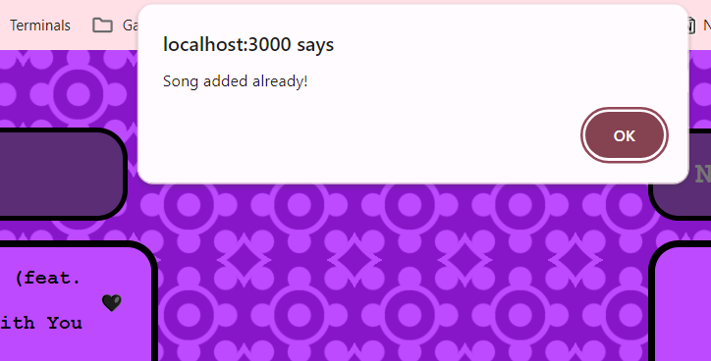

Native Solution
A better solution is to create a modal that appears when the user tries to add a track already added. This can be made using native HTML element dialog and a bit of JavaScript.
To add this modal, first it’s necessary to use the useState React Hook in the Track component, to manage the state of a variable responsible to show the modal. This looks like this in the beginning: const [open, setOpen] = useState(false)
The setter method will be passed as a prop to a new component called Modal.js and also will be used in the addTrack function to change the state of open to true and showing the modal in case a user wants to add an already added track.
Modal.js has an object with properties that will be used to display the necessary text. Inside the returned statement the dialog element has a button with an onClick event listener, that closes the modal using the setOpen function that receives as prop, setting the open variable to false again.
This modal could looks like this:
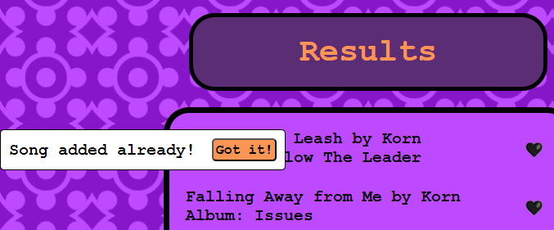

CAVEATS
One track playlist
Although the nature of a playlist it's the diversity of sounds, it's possible that some users want a playlist with the same track more than one time, even some people will want a playlist with a unique track repeated.
With this implementation the user can't do either of the two.
A possible alternative
An alternative to the prohibition of adding the track again, the modal could give a message to alert the user and give the option to add the track anyways.
For the moment this alternative doesn't seem necessary to implement because 90% of the time that the users added the same track, was made by mistake.

